**Analytical CRM Development for a Bank**

**Objective Question:**

1. What is the distribution of account balance across different regions? (Power BI)

To analyze the distribution of account balances across different regions in Power BI, you can use a variety of visualizations such as histograms, column charts, or bar charts.

Create a Chart:

In Power BI, create a new chart visual.

Drag the "Geography" field into the Axis box.

Drag the "Balance" field into the Values box.

Aggregate Account Balances: Power BI may aggregate the account balances using the sum or average function.

After visualization, we get the Highest Sum of balance by Geography in Germany that was 31,13,32,479.49 and the lowest was in Spain 15,31,23,552.01.

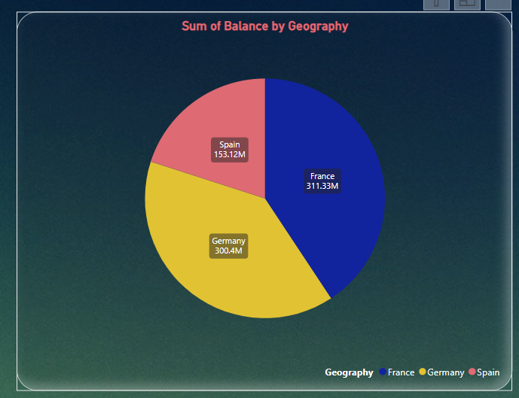

1. Identify the top 5 customers with the highest Estimated Salary in the last quarter of the year. (SQL)

This query retrieves the top 5 customers with the highest Estimated Salary whose dates fall within the last quarter of every year. It orders the results by Date_of_joining in descending order, so the CustomerId, Surname, Salary comes in the order of month and returns the top five customers of the last quarter of every year.

| CustomerID | Surname | EstimatedSalary | Date_of_joining |
| --- | --- | --- | --- |
| 15610165 | Hsiung | 199409.2 | 10-10-2016 |
| 15767722 | Richardson | 197933.5 | 22-10-2016 |
| 15671591 | Castiglione | 198874.5 | 21-11-2016 |
| 15634359 | Dyer | 199970.7 | 29-11-2016 |
| 15737748 | McWilliam | 199336.6 | 21-12-2016 |
| 15598275 | Sochima | 199418 | 05-10-2017 |
| 15710687 | Mills | 199478.1 | 15-11-2017 |
| 15800620 | Fitzgerald | 199635.9 | 19-11-2017 |
| 15770405 | Warlow-Davies | 199104.5 | 27-11-2017 |
| 15711316 | Ch'ang | 199527.3 | 11-12-2017 |
| 15572361 | Chill | 199420.4 | 02-10-2018 |
| 15687913 | Mai | 199805.6 | 12-11-2018 |
| 15599792 | Dimauro | 199638.6 | 16-11-2018 |
| 15585961 | Talbot | 199505.5 | 21-12-2018 |
| 15661903 | Hsia | 199378.6 | 29-12-2018 |
| 15763065 | Palerma | 199754 | 01-10-2019 |
| 15624641 | Kharlamova | 199290.7 | 02-10-2019 |
| 15699095 | Chandler | 198826 | 15-12-2019 |
| 15691874 | Kazakova | 198929.8 | 19-12-2019 |
| 15804211 | Oluchukwu | 199841.3 | 25-12-2019 |

1. Calculate the average number of products used by customers who have a credit card. (SQL)

Query selects the average value of the NumberOfProducts column for customers who have a credit card (HasCrCard = 'credit card holder'). It calculates the average number of products used by these customers.

The output for the average number of products is **1.5341**.

| Average_NumberofProduct |
| --- |
| 1.5314 |

1. Determine the churn rate by gender for the most recent year in the dataset. (Power BI)

Calculate Churn Rate by Gender:

Create a measure to calculate the churn rate by gender for the most recent year. This measure will count the number of churned customers by gender and then divide it by the total number of customers by gender.

Churn Rate of Male =

**DIVIDE (**

**CALCULATE (COUNTROWS ('try bank'), 'try bank'[Exited] = "Exit"),**

**CALCULATE (COUNTROWS ('try customer info'), 'try customer info'[Gender] = "Male”),0)**

**The Same Dax function also for Female.**

Visualize the Data:

Drag the "Churn Rate by Gender" measure into the Field section.

Add Slicer to get the recent year Churn rate. In 2019 the Male Churn Rate was **2.27** and for Female was **1.79.**

1. Compare the average credit score of customers who have exited and those who remain. (SQL)

Query calculates the average credit score for customers based on their exit status ('Exit' or 'Retain'). It uses a CASE statement to categorize customers into two groups: those who have exited and those who remain. Then, it calculates the average credit score for each group using the AVG function and groups the results by customer status.

| Customer_Status | Average_Cr_Score |
| --- | --- |
| Exited | 645.3515 |
| Retain | 651.8532 |

1. Which gender has a higher average estimated salary, and how does it relate to the number of active accounts? (SQL)

Females have a higher average estimated salary. If you want to write an analysis of this question, then you must add conditions on active accounts because in the data set, we have data of inactive members also.

The query calculates the average estimated salary for each gender group and counts the number of active accounts for each gender group. It uses the SUM function along with a CASE statement to count the number of active accounts. The results are grouped by gender and order by Average_salary and use LIMIT 1.

| Gender | Average_Salary |
| --- | --- |
| Female | 99773.1885 |

1. Segment the customers based on their credit score and identify the segment with the highest exit rate. (SQL)

Query first categorizes customers into segments based on their credit scores. Then, it calculates the total number of customers, the number of exited customers, and the exit rate for each segment. Finally, it sorts the results by exit rate in descending order and selects the segment with the highest exit rate using the LIMIT clause.

As per analysis Poor Credit card Score Segment has the highest Exit Rate.

| Credit Score Segment | Exited_Count | Total_Count | Exit_Rate |
| --- | --- | --- | --- |
| Poor | 660 | 3034 | 0.2175 |

1. Find out which geographic region has the highest number of active customers with a tenure greater than 5 years. (SQL)

Query filters the customers who are active and have a tenure greater than 5 years. Then, it groups the results by geographic region and counts the number of active customers in each region. And we need to join both Table Bank and CustomerInfo. Finally, it orders the results in descending order based on the count of active customers and selects the region with the highest count using the LIMIT clause.

| Geography | Active Member |
| --- | --- |
| France | 797 |

1. What is the impact of having a credit card on customer churn, based on the available data? (Power BI)

To determine the impact of having a credit card on customer churn based on the available data, you would typically analyze the churn rates for customers with and without a credit card.

Create a visualization, You can place the Count of Exited column on the Y-axis and drag the HasCrCard column on the X-axis to analyze trends.

Apply a filter to your dataset to include only data for customers who have exited (churned). The Impact was **1424** members exit those that have credit cards and **613** members exit those that have n't credit card.

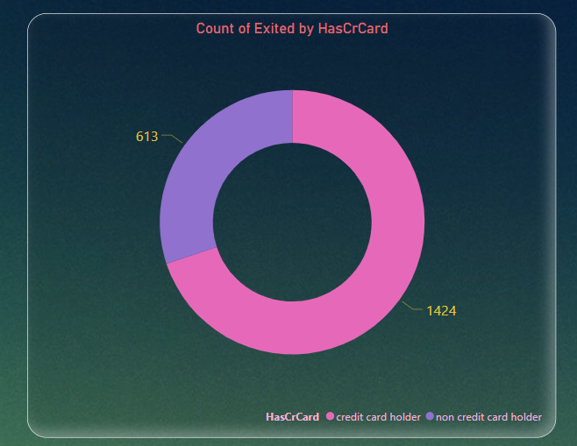

1. For customers who have exited, what is the most common number of products they had used? (Power BI)

To determine the most common number of products used by customers who have exited (churned).

Visualize Data:

Create a visualization, such as a bar chart or a table, to display the counts of churned customers for each number of products.

You can use a bar chart with the number of products on the X-axis and the count of churned customers on the Y-axis.

Apply a filter to your dataset to include only data for customers who have exited (churned).

As per our analysis Product Number **1** was highly used by **1409** exited customers.

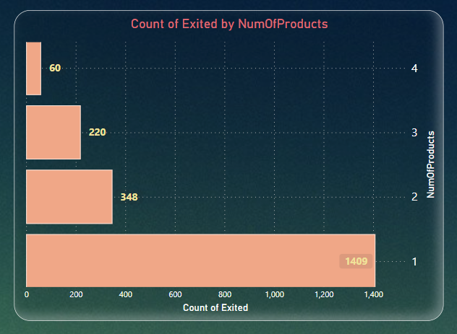

1. Examine the trend of customer joining over time and identify any seasonal patterns (yearly or monthly). Prepare the data through SQL and then visualize it.

Visualize Data in Power BI:

Connect Power BI to your database and import the data using the SQL query you've written.

Once the data is imported into Power BI, create a chart visual.

* Drag the "Year" field to the X-axis of the chart.
* Drag the "count_customerId" field to the Values section of the chart.

Power BI should automatically recognize the date field and aggregate the data by year.

As per our analysis every year the joining of customers increased and in the recent (2019) year 3313 customers joined.

| Years | Customer_Joined |
| --- | --- |
| 2019 | 3313 |
| 2018 | 2593 |
| 2017 | 2143 |
| 2016 | 1951 |

1. Analyze the relationship between the number of products and the account balance for customers who have exited. (Power BI)

* Prepare Your Data:

Ensure your dataset includes information about customer churn status, the number of products used, and account balances.

* Filter Data for Churned Customers:

Apply a filter to your dataset to include only data for customers who have exited (churned).

* Create a Chart:

In Power BI, create a new chart visual.

Drag the "Number of Products" field onto the X-axis of the chart.

Drag the "Balance" field onto the Y-axis of the chart.

As per the analysis, the highest average balance was **93,733** of Product **4**.

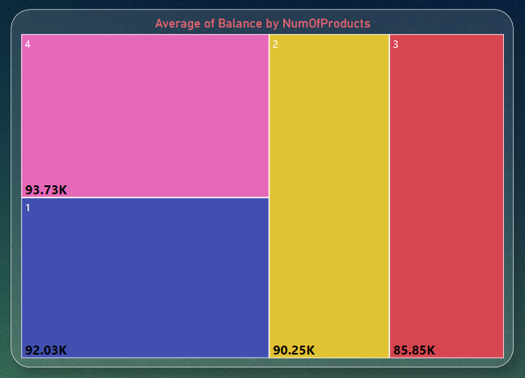

1. Identify any potential outliers in terms of balance among customers who have remained with the bank. (Power BI)

As per our analysis we find the InterQuartile Range, Outliers Range and Maximum balance. There were not any potential outliers because maximum balance(251K) was less than Outliers Range(319K).

Outliers Range = [Quartile Q3] +1.5*[InterQuartile Range]

InterQuartile Range = [Quartile Q3]-[Quartile Q1]

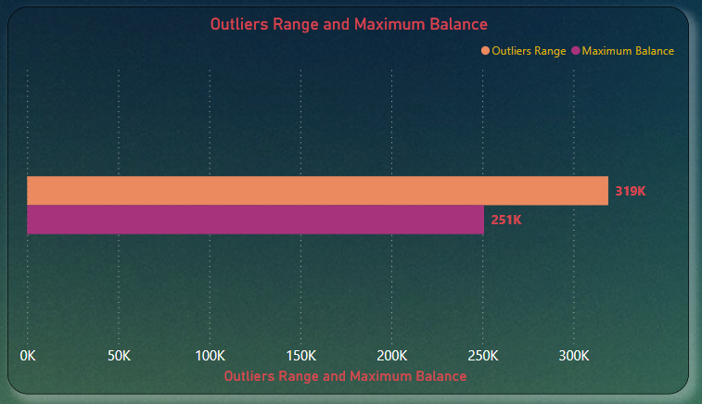

1. How many different tables are given in the dataset, out of these tables which table only consist of categorical variables?

There are 7 different tables given in the dataset but out of 7 only 2 datasets are consisting of categorical variables.

First dataset was “Bank_Churn” and second was “CustomerInfo”.

In SQL, categorical variables are those that represent qualitative or categorical data, as opposed to quantitative or numerical data. Categorical variables are typically used to represent characteristics or attributes that fall into distinct categories or groups.

Categorical variables are often represented using string or character data types in SQL, and they play a crucial role in various data analysis tasks such as segmentation, grouping, and classification. When working with categorical variables in SQL, it's essential to understand how to encode, manipulate, and analyze them effectively to derive insights from the data.

1. Using SQL, write a query to find out the gender wise average income of male and female in each geography id. Also rank the gender according to the average value. (SQL)

Query calculates the average income for each gender within each geography ID. It then ranks the genders within each geography ID based on the average income, with the highest average income ranked first. The RANK () function is used with the PARTITION BY clause to partition the ranking by geography ID.

| Geography | Gender | Average Salary | Rank |
| --- | --- | --- | --- |
| France | Male | 100174.3 | 1 |
| France | Female | 99564.25 | 2 |
| Germany | Female | 102446.4 | 1 |
| Germany | Male | 99905.03 | 2 |
| Spain | Female | 100734.1 | 1 |
| Spain | Male | 98425.69 | 2 |

1. Using SQL, write a query to find out the average tenure of the people who have exited in each age bracket (18-30, 30-50, 50+).

Query calculates the average tenure of people who have exited the bank in each age bracket (18-30, 31-50, 50+). It groups the data by age brackets using a CASE statement and calculates the average tenure for each bracket using the AVG () function. As per the analysis 50+ age bracket members having highest number of tenures was 4.8330.

| Age Bracket | Average Tenure |
| --- | --- |
| 18-30 | 4.777 |
| 30-50 | 4.8899 |
| 50+ | 4.833 |

1. Is there any direct correlation between salary and balance of the customers? And is it different for people who have exited or not? (Power BI)

As per our analysis we get very weak correlation bond between salary and balance. In Power Bi with the help of Quick Measure we get only **0.01** Strength between them.

| **Strength** |  |
| --- | --- |
| **0 to 0.19** | **Very weak** |
| **0.2 to 0.39** | **Weak** |
| **0.40 to 0.59** | **Moderate** |
| **0.6 to 0.79** | **Strong** |
| **0.8 to 1** | **Very Strong** |

And it is also different for people who have exited or not but those also come in very weak Strength. The analysis reveals a very weak correlation between salary and account balance, and this correlation differs for customers who have exited compared to those who have not, it suggests that other factors may have a stronger influence on balance and customer churn. 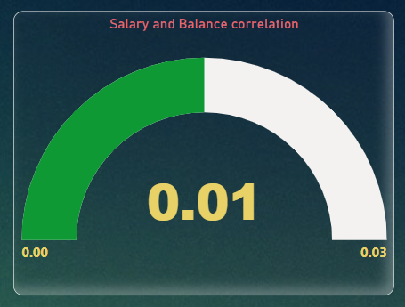

1. Is there any correlation between salary and Credit score of customers? (Power BI)

If the strength of the correlation between salary and credit score is 0.0, it suggests that there is no linear relationship between these two variables. However, it's important to note that a correlation coefficient of 0.0 only measures linear relationships, and there could still be other types of relationships (such as non-linear or categorical) between the variables that are not captured by the correlation coefficient.

| **Strength** |  |
| --- | --- |
| **0 to 0.19** | **Very weak** |
| **0.2 to 0.39** | **Weak** |
| **0.40 to 0.59** | **Moderate** |
| **0.6 to 0.79** | **Strong** |
| **0.8 to 1** | **Very Strong** |

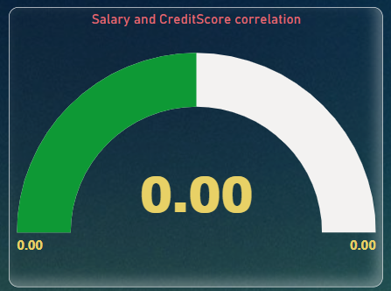

1. Rank each bucket of credit score as per the number of customers who have churned the

bank. (SQL)

Query first categorizes the credit scores into buckets (e.g., Poor, Fair, Good, Very Good, Excellent) using a CASE statement. Then, it counts the number of customers who have churned the bank (Exited) within each credit score bucket. Finally, it ranks the buckets based on the number of churned customers using the RANK () window function.

As per the analysis the maximum number of customers those churn the bank from ‘GOOD’ Credit score bucket and the minimum number of customers from ‘EXCELLENT’.

| Credit Score Bucket | Customers | Rank |
| --- | --- | --- |
| Good | 753 | 1 |
| Fair | 513 | 2 |
| Very Good | 492 | 3 |
| Poor | 152 | 4 |
| Excellent | 127 | 5 |

1. According to the age buckets find the number of customers who have a credit card. Also retrieve those buckets who have lesser than average number of credit cards per bucket. (SQL)

Query calculates the number of customers who have a credit card in each age bucket and calculates the average number of credit cards per customer for each bucket. Then, it calculates the average number of credit cards across all buckets and selects only those buckets where the average number of credit cards per customer is less than the overall average. Finally, it retrieves the age buckets, the total number of customers in each bucket, and the average number of credit cards per customer for those selected buckets.

| Age Bracket | Customers |
| --- | --- |
| 18-30 | 1400 |
| 50+ | 874 |

1. Rank the Locations as per the number of people who have churned the bank and average balance of the learners. (SQL)

According to me we must divide this question in two parts.

Rank the Locations based on the number of customers who have churned the bank.

Rank the Locations based on the average balance of the learners.

In first part we use ranks the customers based on the number of churned customers using the RANK () window function. After that we need to join Bank and CustomerInfo table and apply where condition to choose only exited customers and use group by function.

| Geography | Cust_ Churned | Rank_Cust_Churned |
| --- | --- | --- |
| Germany | 814 | 1 |
| France | 810 | 2 |
| Spain | 413 | 3 |

In second part we use ranks the customers based on the customers average balance using the RANK () window function. After that we need to join Bank and CustomerInfo table and use group by function.

| Geography | Avg_cust_balance | Rank |
| --- | --- | --- |
| Germany | 119730.1161 | 1 |
| France | 62092.63652 | 2 |
| Spain | 61818.14776 | 3 |

1. As we can see that the “CustomerInfo” table has the CustomerID and Surname, now if we have to join it with a table where the primary key is also a combination of CustomerID and Surname, come up with a column where the format is “CustomerID_Surname”. (SQL)

CustomerInfo is the table containing CustomerID and Surname.

Bank Table is the table where the primary key is a combination of CustomerID and Surname.

We use the CONCAT () function to concatenate CustomerID and Surname, separated by an underscore.

The JOIN condition links records from CustomerInfo to Bank Table based on matching CustomerID and Surname.

This query will generate a column named CustomerID_Surname containing values in the format "CustomerID_Surname" for each matching record in the joined tables. Adjust the table and column names to match your actual database schema.

| CustomerId_Surname |
| --- |
| 15634602_Hargrave |
| 15647311_Hill |
| 15619304_Onio |
| 15701354_Boni |
| 15737888_Mitchell |
| 15574012_Chu |

1. Without using “Join”, can we get the “ExitCategory” from ExitCustomers table to Bank_Churn table? If yes do this using SQL.

* First Method Using Case-

**SELECT**

**CASE**

**WHEN Exited = 0 THEN 'Exit'**

**ELSE 'Retain'**

**END AS Exited**

**FROM question23_bank.**

This query will return a result set where each row contains the label "Exit" if the corresponding customer has exited (Exited = 0) or "Retain" if they have not exited (Exited ≠ 0). Adjust the table and column names as needed to match your actual database schema.

* Second method using Update-

**UPDATE question23_bank**

**SET Exited = 'Exit'**

**WHERE Exited = 1;**

**UPDATE question23_bank**

**SET Exited = 'Retain'**

**WHERE Exited = 0;**

These statements will update the "Exited" column, accordingly, setting it to "Exit" where the value is 1 and "Retain" where the value is 0. If "Exited" is stored as a string, you need to adjust the values accordingly.

1. Were there any missing values in the data, using which tool did you replace them and what are the ways to handle them?

In the provided data, we didn't identify any missing values. However, we noticed that some columns contained values in the format of 0 and 1, which presumably represent categorical variables or binary indicators. To ensure consistency and clarity in the data, we utilized Excel and employed the "Find and Replace" function to transform these values into the correct format or interpretation.

Handling missing values is a critical aspect of data preprocessing. Here are some common approaches to deal with missing values:

* Removal: If the proportion of missing values is small compared to the total dataset, you can simply remove rows or columns containing missing values. However, this approach may lead to loss of valuable information.
* Imputation: Missing values can be replaced with a substituted value. This could be the mean, median, or mode of the column for numerical data, or the most frequent category for categorical data. Imputation helps retain the data structure but may introduce bias.

The choice of method depends on various factors such as the amount of missing data, the nature of the dataset, and the specific objectives of the analysis. Each approach has its advantages and limitations, and it's essential to carefully consider the implications of handling missing values in different ways.

1. Write the query to get the customer ids, their last name and whether they are active or not for the customers whose surname ends with “on”. (SQL)

It selects the CustomerId and Surname columns from the customerinfo table where the Surname ends with "on". The % symbol in the LIKE clause is a wildcard that matches any sequence of characters, so %on matches any string that ends with "on". This effectively retrieves the customer IDs and surnames of customers whose surnames end with "on".

| CustomerId | Surname |
| --- | --- |
| 15788218 | Henderson |
| 15750181 | Sanderson |
| 15788448 | Watson |
| 15585768 | Cameron |
| 15592461 | Jackson |
| 15640635 | Capon |
| 15676966 | Capon |

**Subjective**

1. **Customer Behavior Analysis:** What patterns can be observed in the spending habits of long-term customers compared to new customers, and what might these patterns suggest about customer loyalty?

Customer behavior analysis can reveal valuable insights into the spending habits of long-term customers compared to new customers, shedding light on patterns that can inform strategies for customer loyalty.

We can solve this question by seeing the average of balance with respect to tenure of customers. I considered customer with tenure more than 5 are loyal customer, and less than 5 are new customers.

* By creating a measure in Power BI, we can see the average of premium customers is higher than normal customers.
* DAX formula used:

Loyal_Customers = CALCULATE (AVERAGE ('try bank'[Balance]), 'try bank'[Tenure]>5)

* New_Customers = CALCULATE (AVERAGE (Bank [Balance]), Bank [Tenure]<5)

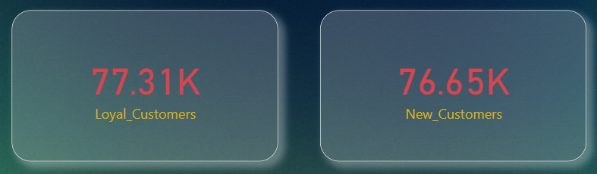

1. **Product Affinity Study:** Which bank products or services are most used together, and how might this influence cross-selling strategies?

A product affinity study involves analyzing the relationships between different bank products or services to identify patterns of co-usage among customers. By understanding which products or services are frequently used together.

Customers who have credit card of the bank are more active with bank rather than customer don’t have credit card.

For this I created a bar chart with number of customers are credit card holder and is active.

**Result is customer with credit card and active = 7055**

**Customer without credit card and active = 2945**

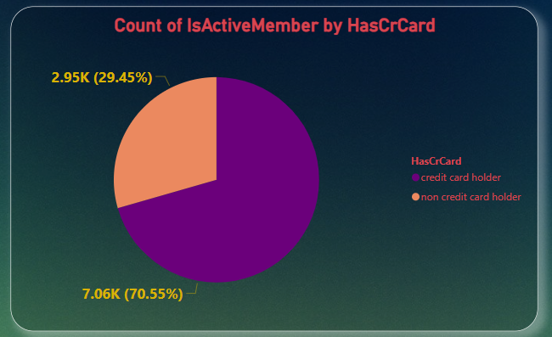

1. **Geographic Market Trends:** How do economic indicators in different geographic regions correlate with the number of active accounts and customer churn rates?

Analyzing geographic market trends and their correlation with economic indicators, active accounts, and customer churn rates can provide valuable insights into regional market dynamics and customer behavior.

To visualize this, I used Bar chart. From the chart we can see France has most active customers. While Germany and Spain have same number of active customers.

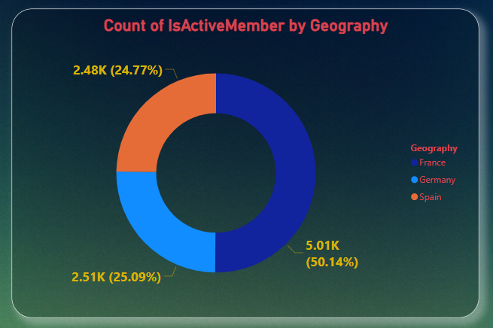

1. **Risk Management Assessment:** Based on customer profiles, which demographic segments appear to pose the highest financial risk to the bank, and why?

As per our analysis and given facts “Germany” seems to be in highest financial risk because the average balance of customers from Germany is higher than average salary.

1. **Customer Lifetime Value Forecast:** How would you use the available data to model and predict the lifetime (tenure) value of different customer segments?

Predicting customer lifetime value (CLV) involves forecasting the future value that a customer will generate over their entire relationship with the business.

* Data Collection and Preparation:

Gather historical data on customer transactions, interactions, demographics, and tenure.

* Define Customer Segments:

Segment customers based on relevant attributes such as demographics, behavior, transaction history, and geographic location.

* Feature Engineering:

Customer demographics such as age, gender, income, and location.

Tenure or length of the customer relationship with the business.

Continuously monitor and evaluate the performance of the CLV models over time.

Update the models periodically with new data and retrain them to improve accuracy and relevance.

1. **Marketing Campaign Effectiveness:** How could you assess the impact of marketing campaigns on customer retention and acquisition within the dataset? What extra information would you need to solve this?

To assess the impact of marketing campaigns on customer retention and acquisition within the dataset, you can employ various analytical techniques and metrics.From Available dataset we can see customer retained are more than customer exit. Bank can increase the retention rate by giving more offers. Retention rate is almost 80%.

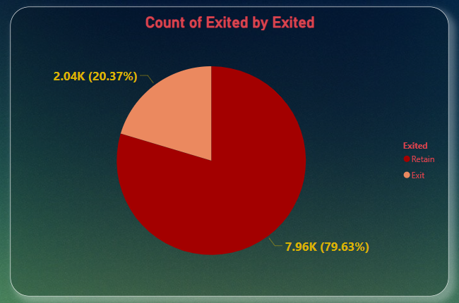

1. **Customer Exit Reasons Exploration:** Can you identify common characteristics or trendsamong customers who have exited that could explain their reasons for leaving?

To explore common characteristics or trends among customers who have exited, you can analyze various factors that may contribute to their decision to leave. Gather data on customers who have exited, including demographic information, transaction history, product usage, interactions, and any available feedback or survey responses.

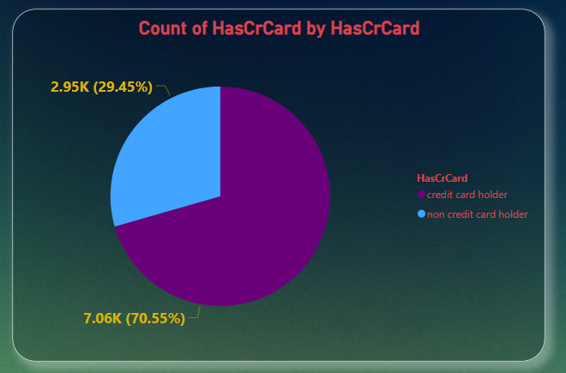

1. Are 'Tenure', 'NumOfProducts', 'IsActiveMember', and 'EstimatedSalary' important for predicting if a customer will leave the bank?

To determine the importance of 'Tenure', 'NumOfProducts', 'IsActiveMember', and 'EstimatedSalary' in predicting customer churn, we can use statistical analysis techniques. Yes, these factors are important to predict, including tenure and 'NumOfProducts' we can see how customers are buying with time. With active member and tenures, we can see how much time a customer spent time with bank.

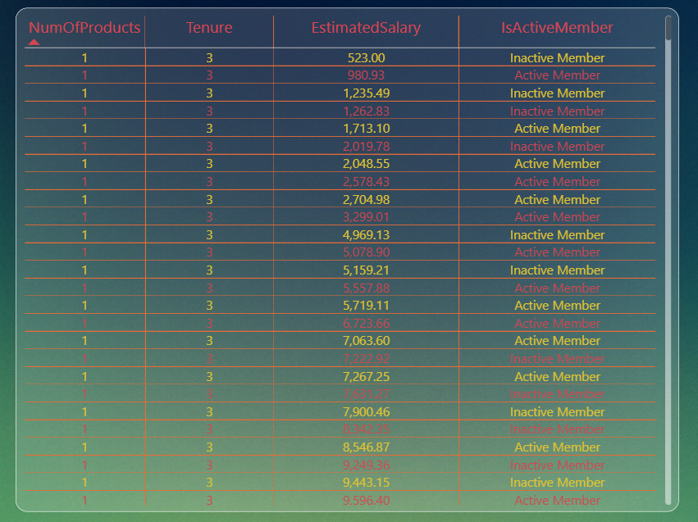

1. Utilize SQL queries to segment customers based on demographics and account details. (SQL)

To segment customers based on demographics and account details using SQL queries, we can use conditional filtering and aggregation functions to group customers into different segments. Here's a general approach to achieve this.

-- Segment customers based on age groups and calculate the average balance

| Age_Group | Total_Customers | Average_Balance |
| --- | --- | --- |
| 18-30 | 1968 | 73198.76 |
| 31-40 | 4451 | 75583.36 |
| 41-50 | 2320 | 79122.19 |
| 51+ | 1261 | 79951.38 |

-- Segment customers based on gender and calculate for each gender

| Gender | Total_Customers |
| --- | --- |
| Female | 4543 |
| Male | 5457 |

-- Segment customers based on geographic location

| Geography | Total_Customers |
| --- | --- |
| France | 5014 |
| Germany | 2509 |
| Spain | 2477 |

1. How can we create a conditional formatting setup to visually highlight customers at risk of churn and to evaluate the impact of credit card rewards on customer retention?

To create a conditional formatting setup in Power BI to visually highlight customers at risk of churn and evaluate the impact of Balance, Estimated Salary, Credit Score and Exited on customer retention. Create visualizations to display the results of the analysis, such as bar charts, line charts, or tables.

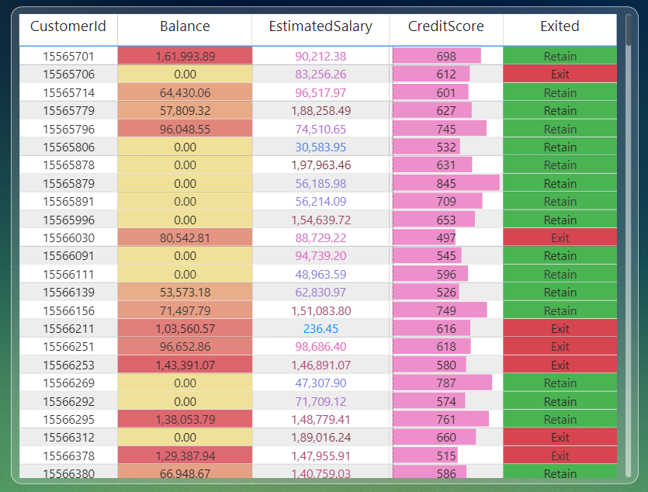

1. What is the current churn rate per year and overall, as well in the bank. Can you suggest some insights to the bank about which kind of customers are more likely to churn and what are the different strategies that can be used to decrease the churn rate. (Power BI)

As per the analysis every year the churn rate of bank was increases. 376 customers exit the bank in 2016 and the 658 customers exit the bank in 2019. From year 2016 to 2019 every year up to 100 customers was increased to exit the bank.

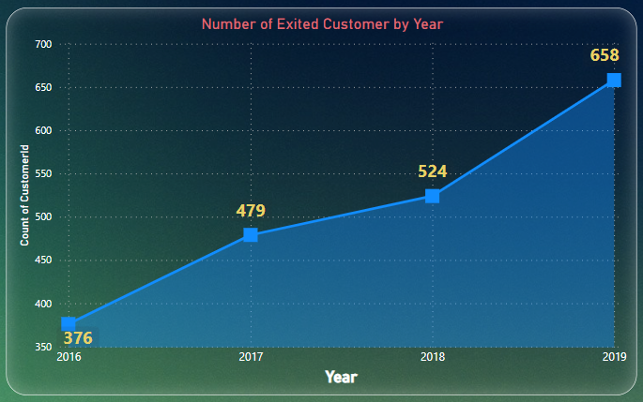

1. Create a dashboard incorporating all the KPIs and visualization related metrics. Use a slicer in order to assist in selection in the dashboard.

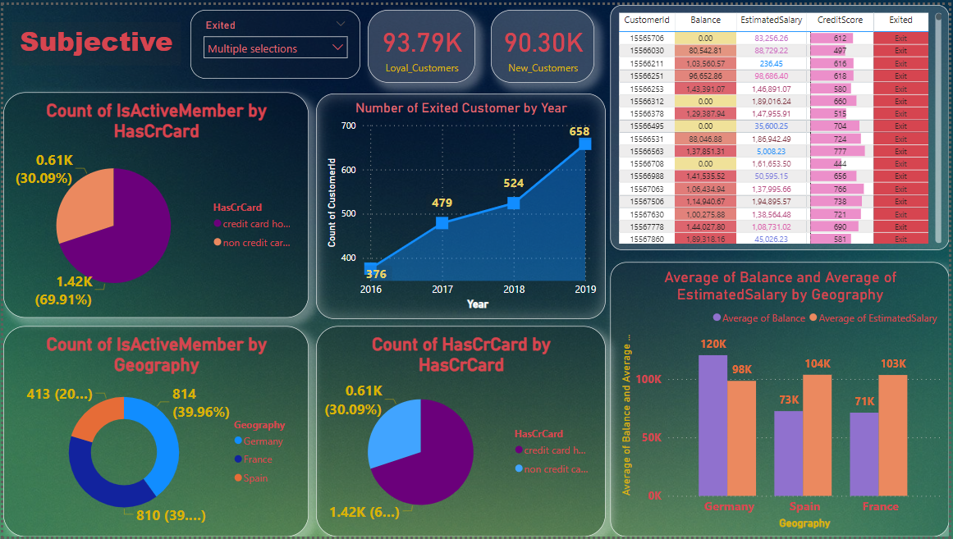

1. How would you approach this problem, if the objective and subjective questions weren't given?

Sure, here's how you can approach creating a dashboard incorporating all KPIs and visualization-related metrics along with a slicer for selection:

* Identify KPIs and Metrics:

Review the dataset to identify key performance indicators (KPIs) and visualization-related metrics relevant to the objectives of the dashboard.

* Create Visualizations:

Based on the identified KPIs and metrics, create individual visualizations such as bar charts, line charts, pie charts, tables, or cards using Power BI.

* Design the Dashboard Layout:

Decide on the layout and arrangement of the visualizations on the dashboard canvas.

* Add Slicer for Selection:

Add a slicer visual to the dashboard canvas. Choose the field you want to use for slicing, such as date, region, or product category.

* Apply Formatting and Branding:

Apply consistent formatting, such as colors, fonts, and backgrounds, to unify the appearance of the dashboard and align it with the branding guidelines.

* Test and Iterate:

Test the functionality of the dashboard to ensure that slicer interactions work as expected and that all visualizations provide meaningful insights.

1. In the “Bank_Churn” table how can you modify the name of “HasCrCard” column to “Has_creditcard”?

To modify the name of the "HasCrCard" column to "Has_creditcard" in the "Bank_Churn" table, you can use the ALTER TABLE statement in SQL. Here's the SQL query to achieve this:

**ALTER TABLE Bank_Churn**

**RENAME COLUMN HasCrCard TO Has_creditcard;**

* ALTER TABLE: This keyword is used to make changes to an existing table structure.
* RENAME COLUMN: This clause specifies that we want to rename a column in the table.
* Bank_Churn: This is the name of the table in which the column exists.
* HasCrCard: This is the current name of the column that we want to change.
* TO Has_creditcard: This specifies the new name that we want to assign to the column.

By executing this SQL statement, the name of the "HasCrCard" column in the "Bank_Churn" table will be changed to "Has_creditcard".